

Travlr Getaways

CS 465 Project Software Design Document
Version 3.0

Table of Contents

CS 465 Project Software Design Document 1
Table of Contents 2
Document Revision History 2
Instructions 2
Executive Summary 3
Design Constraints 3
System Architecture View 3
Component Diagram 3
Sequence Diagram 4
Class Diagram 4
API Endpoints 4
The User Interface 4

Document Revision History

Version | Date | Author | Comments
1.0 | 05/24/2026 | Brandon Burroughs | Initial creation of the Software Design Document including the Executive Summary, Design Constraints, and System Architecture View sections for the Travlr Getaways full stack web application.
2.0 | 06/07/2026 | Brandon Burroughs | Added the sequence diagram, class diagram, API endpoints documentation, and supporting descriptions for Milestone Two of the Travlr Getaways full stack web application.
3.0 | 06/28/2026 | Brandon Burroughs | Finalized the Software Design Document for the Travlr Getaways full stack web application. Added final architecture details, API endpoint documentation, Angular SPA functionality, database integration, and security implementation details.

Instructions

Fill in all bracketed information on page one (the cover page), in the Document Revision History table, and below each header. Under each header, remove the bracketed prompt and write your own paragraph response covering the indicated information.

Executive Summary

Travlr Getaways requires a full stack web application that supports both a public customer-facing website and an administrator-facing single-page application. The application was developed using the MEAN stack, which includes MongoDB, Express, Angular, and Node.js. This architecture allows the public website, administrative SPA, RESTful API, and database to work together as one complete full stack system.

The customer-facing side of the application is built with Node.js, Express, and Handlebars. It allows users to view travel package information through server-rendered pages. The Travel page retrieves trip data dynamically through the application’s REST API instead of relying on hard-coded static content. This improves maintainability because trip information can be updated in the database and reflected on the website without manually changing the HTML.

The administrator side of the application is built as an Angular single-page application. The SPA provides richer functionality for managing trip data, including viewing trip cards, adding new trips, and editing existing trips. Angular services are used to communicate with the Express REST API, which then interacts with MongoDB through Mongoose models and schemas. This separation of concerns allows the front end, backend API, and database to remain organized and easier to maintain.

The application also includes a basic security layer for the administrator side. An admin login form sends credentials to the backend authentication endpoint. When authentication succeeds, the backend returns a JSON Web Token, which is stored by the Angular application and used to authorize access to the admin functionality. This helps protect administrative features from unauthorized users.

Design Constraints

Several design constraints impact the development of the Travlr Getaways web application. One major constraint is the requirement to use the MEAN stack architecture, which dictates the technologies used throughout development, including MongoDB, Express.js, Angular, and Node.js. This requirement limits technology selection but ensures consistency across the full stack application.

Another constraint involves maintaining separation between the customer-facing website and the administrator SPA while ensuring both applications interact with the same backend services and database. This requires careful routing, API design, and authentication implementation to prevent unauthorized access to administrative functionality.

Scalability and maintainability also influence the design process. The application must support future expansion, additional travel packages, and increasing user traffic while remaining organized and easy to update. To address this constraint, the application uses a Model View Controller (MVC) architecture to separate application logic, routing, and user interface rendering.

Security constraints are also significant. Administrative access must be protected through authentication and authorization mechanisms to prevent unauthorized modifications to travel data. Additionally, the application must validate and sanitize user input to reduce the risk of common web vulnerabilities such as injection attacks and malformed requests.

Finally, development constraints include time limitations, project scope, and compatibility requirements between frontend frameworks, backend services, and the MongoDB database. These constraints influence implementation decisions and require efficient organization of project resources and application structure.

System Architecture View

Component Diagram

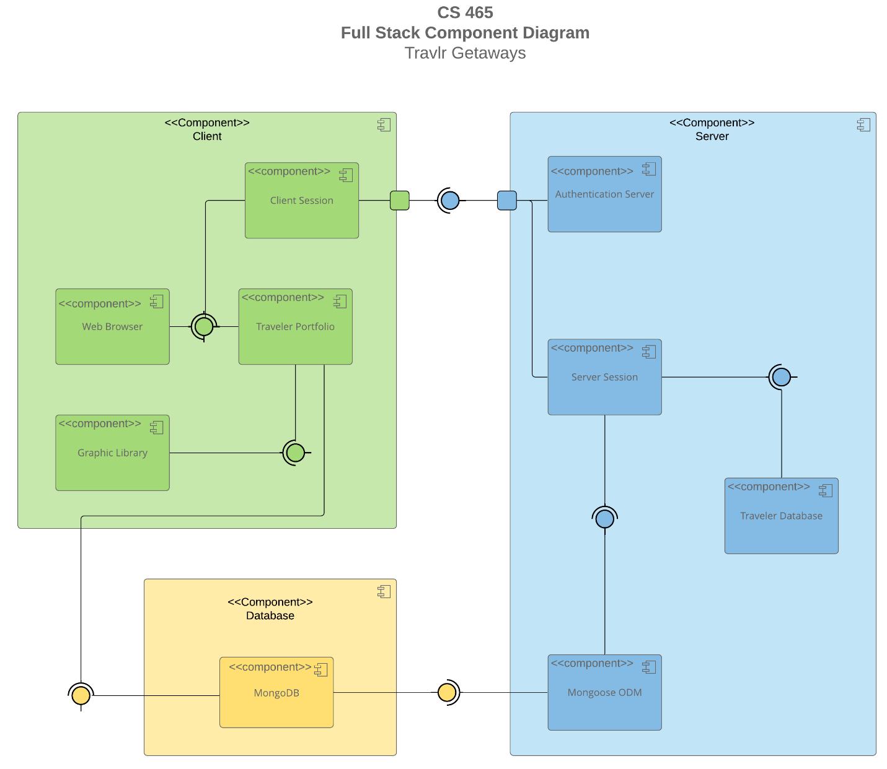

A text version of the component diagram is available: CS 465 Full Stack Component Diagram Text Version.

The Travlr Getaways application follows a three-tier full stack architecture consisting of client, server, and database components. The component diagram illustrates how these major application layers communicate and work together to support the functionality of the web application.

The client layer contains the Web Browser, Client Session, Traveler Portfolio, and Graphic Library components. The Web Browser component allows users to access the application interface and interact with travel package information. The Traveler Portfolio component represents the customer-facing frontend application that displays travel content and communicates with the backend services. The Graphic Library component supports the rendering of images, styling, and user interface elements used throughout the application. The Client Session component manages user interaction and session communication between the client and server layers.

The server layer contains the Authentication Server, Server Session, Traveler Database, and Mongoose ODM components. The Authentication Server is responsible for validating user credentials and controlling secure access to administrative functionality. The Server Session component manages communication between the frontend applications and backend services while processing incoming requests and application logic. The Traveler Database component represents the server-side logic responsible for retrieving and updating travel package information. The Mongoose ODM component provides object data modeling and enables communication between the Express server and the MongoDB database.

The database layer contains the MongoDB component, which stores application data including travel packages, user accounts, and administrative content. MongoDB provides a flexible NoSQL document database structure that integrates efficiently with JavaScript technologies used throughout the MEAN stack.

The relationships between these components allow the web browser and client session to communicate with the server session and authentication services through required interfaces. The server layer communicates with MongoDB through the Mongoose ODM component to retrieve and store application data. This architecture supports modularity, scalability, maintainability, and efficient communication across all layers of the Travlr Getaways full stack web application.

Sequence Diagram

The sequence diagram illustrates the flow of communication through the Travlr Getaways application. A user initiates a request through an HTTP client, which is processed by the browser and application view. The request is passed through the route layer to the controller, which invokes the appropriate model functions. The model interacts with MongoDB through Mongoose to retrieve or update trip information. After the database operation is completed, the results are returned through the controller and route layers back to the browser where the information is displayed to the user. This sequence demonstrates the separation of concerns between the client interface, application logic, and data storage layers within the full stack architecture.

Class Diagram

The class diagram illustrates the primary classes used within the Travlr Getaways application and the relationships between them. The TripInfo class contains general trip information such as travel dates and destinations. FlightInfo, HotelInfo, and CruiseInfo store travel service details that are combined into an Itinerary. TravellerInfo stores customer information and is associated with MemberAccount records. Membership_Admin provides functionality for validating memberships and managing reward points. Travel_Agent coordinates the booking process by creating hotel, flight, cruise, and package reservations. HotelBooking, FlightBooking, and CruiseBooking classes manage the retrieval and booking of travel services for a traveler. Together, these classes represent the business objects and relationships required to support travel planning and reservation management within the Travlr Getaways application.

API Endpoints

Exposing RESTful endpoints enables the Travlr Getaways application to provide data services independently from the user interface. These endpoints allow client applications to request trip information using standard HTTP methods. The API returns JSON data that can be consumed by web applications, mobile applications, or other services. This approach supports scalability, maintainability, and separation of concerns by isolating business logic and data access from the presentation layer.

Method | Purpose | URL | Notes
GET | Retrieve list of all trips | /api/trips | Returns all trip records stored in MongoDB as JSON
GET | Retrieve a single trip | /api/trips/:tripCode | Returns a specific trip identified by the trip code parameter
POST | Add a new trip | /api/trips | Create a new trip record in MongoDB using data submitted from the Angular SPA
PUT | Update an existing trip | /api/trips | Updates an existing trip record identified by the trip code parameter
DELETE | Delete a trip | /api/trips | Deletes a trip record identified by the trip code parameter
POST | Authenticate administrator | /api/trips | Validates administrator credentials and returns a JSON Web Token when login succeeds

The User Interface

The Angular project structure is different from the Express project structure because Angular is a client-side single-page application while Express is a server-side web application framework. The Express portion of the project uses routes, controllers, models, Handlebars views, layouts, and partials to render pages for the customer-facing website. The Angular portion uses components, services, routing, TypeScript files, and templates to create a more interactive administrator interface.

The Angular SPA provides richer functionality than a simple server-rendered web page. Instead of loading a completely new page after every user action, the SPA communicates with the backend REST API and updates the interface dynamically. The administrator can log in, view trip cards, add new trips, and edit existing trips without needing to manually modify database records or static files. The TripList component displays the collection of trips, the TripCard component provides reusable trip card display logic, and the TripAdd and TripEdit components provide forms for creating and updating trip data.

Angular services are used to separate data access from the user interface. The TripDataService sends GET, POST, PUT, and DELETE requests to the Express API. The AuthService sends login credentials to the authentication endpoint and receives a JSON Web Token when login succeeds. This token is stored by the Angular application and used to control access to the administrator area.

Testing was completed by running the Express backend at localhost:3000 and the Angular SPA at localhost:4200. The REST API was tested in Postman to verify that the GET, POST, PUT, DELETE, and login endpoints returned the expected responses. The Angular SPA was tested in the browser by clearing the stored authentication token, confirming that the app redirected to the login page, logging in with valid credentials, viewing the trip cards, adding a new trip, and editing an existing trip. The database connection was verified by confirming that changes made in the Angular admin interface appeared through the API and on the customer-facing Travel page.

